Third Sunday after Easter

10:30 A.M. Worship with Eucharist April 15, 2018



616 Lake St., Evanston, IL 60201 ● 847-864-4464 ● www.immanuelevanston.org

E-mail: Church: [immanuel@immanuelevanston.org](mailto:immanuel@immanuelevanston.org) ● Pastor: [pastor@immanuelevanston.org](mailto:pastor@immanuelevanston.org)

● Parish Administrator: parish-admin@immanuelevanston.org

**Welcome!**

**Immanuel Lutheran Church is a Reconciling in Christ congregation.**

**We welcome people of every age and size, color and culture, every sexual orientation and**

**gender identity, socio-economic status and marital status, every ability and challenge.**

**We welcome believers and questioners, and questioning believers.**

We’re glad God has called you here today! If you’re a guest, please feel free to introduce yourself to our pastor or assisting minister. If you would, sign the guest book in the Gathering Area or fill in a guest card, and we’ll be happy to send information on how you can get involved at Immanuel.

**Facilities**

* Our parking lot is located on the south side of the church off Sherman Avenue. You may park in the lot at any time, whether for church events or for shopping or other errands in downtown Evanston; weekdays, see the church office at the Lake St. entrance to get a parking pass. On Sundays, additional parking is available across the street at the Holiday Inn or in Lot 6 on Lake St. across from the Police and Fire Headquarters. Parking meters are free on Sunday!
* The parking lot entrance is an accessible entrance. An elevator is located just inside that door.
* Restrooms are downstairs near the meeting of the two hallways. Accessible restrooms are located near the elevator on both upper and lower levels. A gender-neutral restroom is located on the lower level by the elevator.
* We love having children in worship! There is a nursery and changing/crying room for parents to use, if needed, located downstairs. There are also changing tables in both restrooms on this level, by the elevator. An usher will be happy to direct you.
* Hearing assistance is available. Ask an usher for equipment.
* Wi-Fi is available throughout most of the building. The network is “Immanuel,” password “allarewelcome”. Please use the Internet responsibly!

**About Our Worship**

Our Sunday worship is organized around the proclamation of the Word of God and the celebration of the Lord’s Supper. It has a familiar form each week, but the content changes for each service according to a calendar shared with many other Christians. Our hymnal, *Evangelical Lutheran Worship,* is organized so that page numbers for the liturgy are in the front part of the book, while hymn numbers are in the second part. The liturgy and hymns are printed in this bulletin, but page numbers are provided for those who wish to follow along in the hymnal.

**Receiving Holy Communion**

We invite you to share with us in the sacramental meal, because Christ himself invites you! At the direction of the usher, come forward if you are able, and stand around the altar, starting at the walls. Receive the bread in the palm of your hand. (Gluten-free wafers are available. Please tell the pastor if you need that.) You may eat it immediately, then take the silver chalice and drink from it or, if you prefer, take a small cup from the tray. The cups in the outer ring contain wine. The cups in the center contain grape juice. As you return to your seat place your empty cup in the trays provided at the ends of the front pews. Return to your place via the side aisles after you have communed. If you need to have Communion brought to you, please sit on the aisle, and let either the pastor or an usher know before the service that you would like to commune at your seat. If you desire a blessing but not the sacrament, you are invited to come forward with everyone else and fold your arms over your chest to indicate this.

**Gathering:** *The Holy Spirit assembles us as the People of God …*

The gospel for the third Sunday of Easter is always one in which the risen Christ shares food with the disciples, meals that are the Easter template for the meal we share each Lord’s day. In today’s gospel, Jesus both shares the disciples’ food and shows them the meaning of his suffering, death, and resurrection through the scriptures: the two main elements of our Sunday worship.

**P:** Presiding Minister **L:** Leader/Assisting Minister **R**: Reader **A:** Assembly

**+** All may make the sign of the cross.

**Pre-Service Music**

**Thanksgiving for Baptism**

P In the name of the Father, and of the + Son, and of the Holy Spirit.

**A Amen.**

P Joined to Christ in the waters of baptism, we are clothed with God's mercy and forgiveness. Let us give thanks for the gift of baptism.

Water is poured into the font as the Presiding Minister prays.

We give you thanks, O God, for in the beginning your Spirit moved over the waters and by your Word you created the world, calling forth life in which you took delight.

Through the waters of the flood you delivered Noah and his family. Through the sea you led your people Israel from slavery into freedom. At the river your Son was baptized by John and anointed with the Holy Spirit. By water and your Word you claim us as daughters and sons, making us heirs of your promise and servants of all.

We praise you for the gift of water that sustains life, and above all we praise you for the gift of new life in Jesus Christ. Shower us with your Spirit, and renew our lives with your forgiveness, grace, and love.

To you be given honor and praise through Jesus Christ our Lord in the unity of the Holy Spirit, now and forever.

**A Amen.**

During the singing of the Gathering Song, the Assembly is sprinkled with water in remembrance of baptism.

You are invited to make the sign of the cross as a reminder that you have been marked with the cross of Christ.

**Gathering Song** “Alleluia! Jesus Is Risen!” **Hymnal 377**



**Greeting** *(The Easter acclamation is repeated three times.)*

P Alleluia! Christ is risen!

**A Christ is risen indeed! Alleluia!**

P The grace of our risen Lord Jesus, the love of God, who raised him from the dead,

and the communion of the Holy Spirit who breathes new life into us, be with you all.

**A And also with you!**

****Kyrie Hymnal p. 98****



****Canticle of Praise Hymnal p. 99****



****Prayer of the Day****

P Let us pray. Holy and righteous God, you are the author of life, and you adopt us to be your children. Fill us with your words of life, that we may live as witnesses to the resurrection of your Son, Jesus Christ, our Savior and Lord, who lives and reigns with you and the Holy Spirit, one God, now and forever.

**A** **Amen.**

The Assembly is seated.

****Welcome and Announcements****

**Word:** *God speaks to us in scripture, preaching, and song …*

**Reading from the Acts of the Apostles Acts 3:12–19**

*After healing a crippled man, Peter preaches to the people how God’s promises to Israel have been fulfilled in Jesus. Through the proclamation of Christ’s death and resurrection, God is offering them forgiveness and restoration in Jesus’ name.*

R A reading from the Acts of the Apostles.

12[Peter] addressed the people, “You Israelites, why do you wonder at this, or why do you stare at us, as though by our own power or piety we had made him walk?13The God of Abraham, the God of Isaac, and the God of Jacob, the God of our ancestors has glorified his servant Jesus, whom you handed over and rejected in the presence of Pilate, though he had decided to release him. 14But you rejected the Holy and Righteous One and asked to have a murderer given to you, 15and you killed the Author of life, whom God raised from the dead. To this we are witnesses. 16And by faith in his name, his name itself has made this man strong, whom you see and know; and the faith that is through Jesus has given him this perfect health in the presence of all of you.

17“And now, friends, I know that you acted in ignorance, as did also your rulers. 18In this way God fulfilled what he had foretold through all the prophets, that his Messiah would suffer. 19Repent therefore, and turn to God so that your sins may be wiped out.”

R Word of God, word of life.

**A Thanks be to God!**

Psalm 4 ELW Psalm Tone 8

The organ will play the tone, and then the refrain, and then the Assembly will sing the refrain through.

The right side of the Assembly sings lightface verses to the tone, and the left sings boldfaced verses.

All sing the refrain where indicated by “R.”

**Tone:**



**Refrain:**



1Answer me when I call, O God, defender | of my cause;

you set me free when I was in distress; have mercy on me and | hear my prayer.

2****“You mortals, how long will you dishon-****|****or my glory;****  
 ****how long will you love illusions and seek****|****after lies?”****  
3Know that the Lord does wonders | for the faithful;  
 the Lord will hear me | when I call.  
4****Tremble, then, and****|****do not sin;****  
 ****speak to your heart in silence up-****|****on your bed.****  R

5Offer the appointed | sacrifices,  
 and put your trust | in the Lord.  
6****Many are saying, “Who will show us****|****any good?”****  
 ****Let the light of your face shine upon****|****us, O Lord.****  
7You have put gladness | in my heart,  
 more than when grain and | wine abound.  
8****In peace, I will lie****|****down and sleep;****  
  ****for you alone, O Lord, make me****|****rest secure.****  R

Reading from the New Testament 1 John 3:1–7

*God has loved us in order to make us children of God. Though we do not yet know the full details of our future existence, we trust that God will reveal it just as God revealed Jesus to take away our sins.*

R A reading from First John.

1See what love the Father has given us, that we should be called children of God; and that is what we are. The reason the world does not know us is that it did not know him. 2Beloved, we are God’s children now; what we will be has not yet been revealed. What we do know is this: when he is revealed, we will be like him, for we will see him as he is. 3And all who have this hope in him purify themselves, just as he is pure.

4Everyone who commits sin is guilty of lawlessness; sin is lawlessness. 5You know that he was revealed to take away sins, and in him there is no sin. 6No one who abides in him sins; no one who sins has either seen him or known him. 7Little children, let no one deceive you. Everyone who does what is right is righteous, just as he is righteous.

R Word of God, word of life.

**A Thanks be to God!**

The Assembly stands to greet the Good News of Jesus.

**Gospel Acclamation**



Christ, our paschal lamb, | has been sacrificed.* Therefore, let us | keep the feast.

Gospel Luke 24:36b–48

*In this account of an appearance after his resurrection, Jesus opens the minds of the disciples to understand him as Messiah. Jesus convinces them that he has been raised and sends them on a mission to proclaim the message of repentance and forgiveness.*

P This is the Good News of Jesus Christ according to Luke.

**A Glory to you, O Lord!**

36bJesus himself stood among [the disciples] and said to them, “Peace be with you.” 37They were startled and terrified, and thought that they were seeing a ghost. 38He said to them, “Why are you frightened, and why do doubts arise in your hearts? 39Look at my hands and my feet; see that it is I myself. Touch me and see; for a ghost does not have flesh and bones as you see that I have.” 40And when he had said this, he showed them his hands and his feet. 41While in their joy they were disbelieving and still wondering, he said to them, “Have you anything here to eat?” 42They gave him a piece of broiled fish, 43and he took it and ate in their presence.  
 44Then he said to them, “These are my words that I spoke to you while I was still with you—that everything written about me in the law of Moses, the prophets, and the psalms must be fulfilled.” 45Then he opened their minds to understand the scriptures, 46and he said to them, “Thus it is written, that the Messiah is to suffer and to rise from the dead on the third day, 47and that repentance and forgiveness of sins is to be proclaimed in his name to all nations, beginning from Jerusalem. 48You are witnesses of these things.”

P The Gospel of the Lord.

**A Praise to you, O Christ!**

The Gospel Acclamation is sung once again. The Assembly is then seated.

Sermon

A bell will chime to begin a time of silence for reflection.

During this time, you may want to meditate on one word or phrase from the scriptures or from the sermon

that stands out to you, asking the Spirit to show you how it applies to your own life.

When the bell sounds a second time, the Assembly stands to respond to the Word.

**Hymn of the Day**  “For the Bread Which You Have Broken” **Hymnal 494**



**The Nicene Creed**

L With the whole Church, let us profess our faith.

**A We believe in one God,**

**the Father, the Almighty,**

**maker of heaven and earth,**

**of all that is, seen and unseen.**

**We believe in one Lord, Jesus Christ, the only Son of God,**

**eternally begotten of the Father,**

**God from God, Light from Light, true God from true God,**

**begotten, not made, of one Being with the Father;**

**through him all things were made.**

**For us and for our salvation**

**he came down from heaven,**

**was incarnate of the Holy Spirit and the virgin Mary**

**and became truly human.**

**For our sake he was crucified under Pontius Pilate;**

**he suffered death and was buried.**

**On the third day he rose again**

**in accordance with the scriptures;**

**he ascended into heaven**

**and is seated at the right hand of the Father.**

**He will come again in glory to judge the living and the dead,**

**and his kingdom will have no end.**

**We believe in the Holy Spirit, the Lord, the giver of life,**

**who proceeds from the Father and the Son,**

**who with the Father and the Son is worshiped and glorified,**

**who has spoken through the prophets.**

**We believe in one holy catholic and apostolic church.**

**We acknowledge one baptism for the forgiveness of sins.**

**We look for the + resurrection of the dead,**

**and the life of the world to come. Amen.**

**Prayers of the People**

L Rejoicing in the life, death, and resurrection of Jesus Christ, we pray for the witness of the church, the wholeness of creation, and all who are in need.

L Holy God, we pray for the church and its many expressions. We pray for our bishops, Elizabeth and Wayne, for our pastor, Keith, for our president, Sara, for our Council, and for all whom you have called here in your name. Make us witnesses of all the things we have seen and heard. Lord, in your mercy,

**A hear our prayer.**

L Creating God, you gave us dominion over every living creature. Grant us wisdom to use our power to develop sustainable farming and housing practices. Slow down our rush to consume. Lord, in your mercy,

**A hear our prayer.**

L Merciful God, walk with all refugees who leave their homes to move to safety. Protect them on their journey. Greet them with hospitality. Lord, in your mercy,

**A hear our prayer.**

**L** Compassionate God, you heal us. For all who have not been granted the healing they desire and for all who cannot access the care they need, send social workers, doctors, parish nurses, and other caregivers. Today we pray especially for Serena Bernstein, Mid Carlson, Margaret Carlson, Lynn Carson, Barb Engelsen, Bob Fried, Jennifer Grethe, Dick Heisler, Judy Hokenson, Ron Laudert, the Shiff family, Joe Skelton, John and Doris Strom, and those we name now aloud or in our hearts *[…]*. Lord, in your mercy,

**A hear our prayer.**

LGod our provider, you call us to give generously. Bless the finance and stewardship teams of this congregation. Make us joyful givers of the time, talents, and treasures you have first given us. Lord, in your mercy,

**A hear our prayer.**

**L And now, sisters and brothers, for what else shall we pray?**

The petitions and thanksgivings of the Assembly, silent or spoken aloud, are invited.

L Lord, in your mercy,

**A hear our prayer.**

L God of our ancestors, in you we have our beginning and our end. We remember all the faithful departed, especially Olavus Petri, Laurentius Petri, and Anselm of Canterbury. Enfold in a shield of peace all those who mourn. Hold them in your love. Lord, in your mercy,

**A hear our prayer.**

P We entrust all our prayers to you, gracious God. Receive them by the power of the Holy Spirit and the love of your Son, Jesus Christ our Lord.

**A Amen.**

**Peace**

P The peace of Christ be with you always.

**A And also with you.**

Greet one another in the peace of the Risen Christ, saying “Peace be with you,” “The peace of the Lord,” or similar words.

If you prefer not to shake hands, you might raise your hand in a gesture of blessing

as you speak peace to your neighbors. After the Peace, all return to their seats.

**Meal:** *God feeds us with the presence of Jesus Christ …*

**Offering** *An offering is gathered for doing God’s mission, including the care of those in need.*

**Offering Music “**Grant Peace, We Pray” *Hugo Distler*

**Presentation of the Gifts “Our Paschal Lamb, That Sets Us Free”**

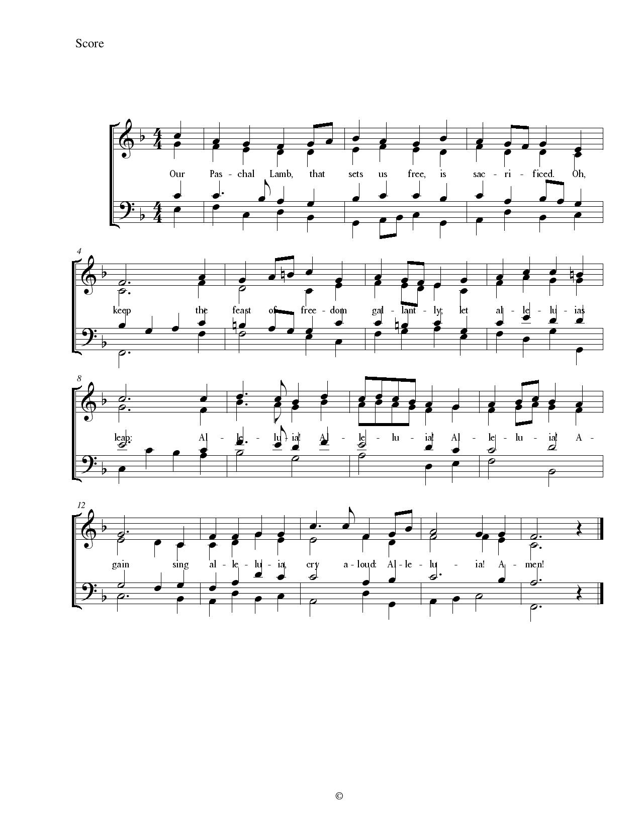

**Offering Prayer**

L Let us pray.

**A Be known to us, O Lord, in the breaking of the bread,**

**as you were made known to the disciples.**

**Receive these gifts, and the offering of our lives,**

**that we may be your risen body in the world.**

**The Great Thanksgiving**

**Dialogue**

P The Lord be with you.

**A And also with you.**

P Lift up your hearts.

**A We lift them to the Lord.**

P Let us give thanks to the Lord our God.

**A It is right to give our thanks and praise.**

**Preface**

P It is indeed right to give you our thanks and praise, O God, for in great love you have made us your children and destined us for life in union with your Son, Jesus Christ. You are the creator of heaven and earth and the author of life. You revealed your purposes through the law of Moses, the prophets and the psalms, and declared your intention to suffer as a servant among us so that you might bring forgiveness to the nations.

Your Word came to fulfilment in your servant, Jesus, the Holy and Righteous One, who was rejected and handed over to death. He was killed through our ignorance, but after three days in the tomb you raised him from the dead. Now he embraces us with hands still wounded,  
and disturbs our fears and doubts with words of peace and the promise of life yet to be revealed.

Therefore, with hearts full of gratitude, we sing joyfully, giving thanks to you, who are both Father and Mother to us, at all times and for everything in the name of our Lord Jesus Christ. We join our voices with Olavus and Laurentius Petri, with Anselm of Canterbury, and with all your holy ones of all times and places. With earth and all its creatures, with sun, moon, and stars, with angels and archangels, cherubim and seraphim, we praise your Name, and join their unending hymn:

**Holy, Holy, Holy** **Hymnal, p. 153**



**Thanksgiving at the Table**

P We give you thanks, Holy One,

through Jesus Christ, your beloved Son,

whom you sent in this end of the ages

to save and redeem us and to proclaim to us your will.

He is your Word, inseparable from you,

through whom you created all things,

and in whom you take delight.

He is your Word, sent from heaven to a virgin’s womb.

He there took on our nature and our lot

and was shown forth as your Son,

born of the Holy Spirit and of the virgin Mary.

He, our Lord Jesus, fulfilled all your will

and won for you a holy people;

he stretched out his hands in suffering

in order to free from suffering those who trust you.

He is the one who, handed over to a death he freely accepted,

in order to destroy death, to break the bonds of the evil one,

to crush hell underfoot, to give light to the righteous,

to establish his covenant, and to show forth the resurrection,

taking bread and giving thanks to you, said:

Take and eat; this is my body, given for you.

Do this for the remembrance of me.

In the same way he took the cup, gave thanks,

and gave it for all to drink, saying:

This cup is the new covenant in my blood,

shed for you and for all people for the forgiveness of sin.

Do this for the remembrance of me.

Remembering, then, his death and resurrection,

we take this bread and cup,

giving you thanks that you have made us worthy

to stand before you and to serve you as your priestly people.

Send your Spirit upon these gifts of your church;

gather into one all who share this bread and wine;

fill us with your Holy Spirit to establish our faith in truth,

that we may praise and glorify you through your Son Jesus Christ;

through whom all glory and honor are yours, almighty Father,

with the Holy Spirit, in your holy church, both now and forever.

**A Amen.**

**The Lord’s Prayer**

P Lord, remember us in your kingdom, and teach us to pray:

**A Our Father in heaven, hallowed be your name.**

**Your kingdom come, your will be done**

**on earth as in heaven.**

**Give us today our daily bread.**

**Forgive us our sins, as we forgive those who sin against us.**

**Save us from the time of trial, and deliver us from evil.**

**For the kingdom, the power, and the glory are yours,**

**now and forever. Amen.**

**The Breaking of the Bread and Invitation**

L Now let us feast this Easter day  
on Christ, the bread of heaven. Hallelujah!

**A Thanks be to God!**

**Distribution of Holy Communion**

*The Assembly is seated. Please come forward as the ushers direct, and as you are able.*

*See the inside front cover for instructions concerning Holy Communion.*

*During the Easter season, we stand to commune, rather than kneel, as a sign of resurrected life.*

Communion Song “Lamb of God” Hymnal p. 112



**Communion Hymn** “Let Us Break Bread Together” **Hymnal** **471**



The Assembly stands when directed by the Presiding Minister.

**Blessing after Communion**

P The body and blood of our **+** Lord and Savior Jesus Christ

strengthen you and keep you in his grace.

**A Amen.**

**Post-Communion Song** “Our Paschal Lamb That Sets Us Free”

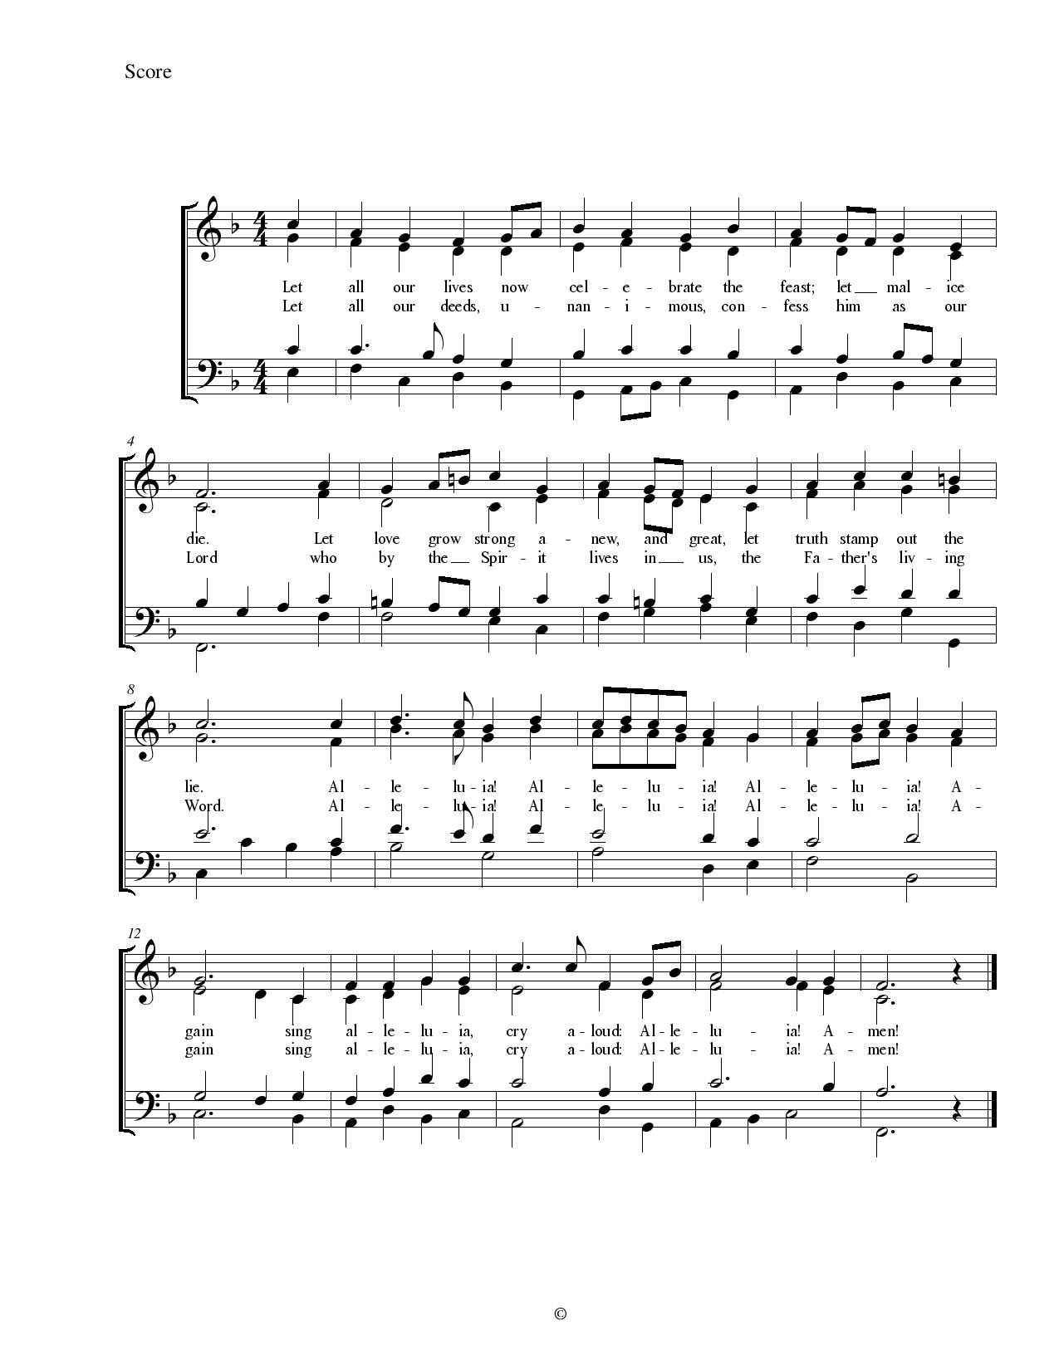

**Prayer after Communion**

L Let us pray. Life-giving God, in the mystery of Christ’s resurrection you send light to conquer darkness, water to give new life, and the bread of life to nourish your people. Send us forth as witnesses to your Son’s resurrection, that we may show your glory to all the world, through Jesus Christ, our risen Lord.

**A Amen.**

**Sending:** *God blesses us and sends us in mission to the world …*

**Sending of Communion**

P Let us pray. Gracious God, loving all your family with a mother’s tender care: As you sent the angel to feed Elijah with heavenly bread, assist those who set forth to share your word and sacrament with those who are sick or homebound. In your love and care, nourish and strengthen those who will receive this sacrament, and give us all the comfort of your abiding presence through the body and blood of your Son, Jesus Christ, our Lord.

**A Amen.**

**Sending Song** “Rise, O Church, like Christ Arisen” *(printed on following page)* **Hymnal 548**

*Please turn as the cross passes you to face the doors through which you will be sent out in mission.*

**Blessing**

P We have eaten together with the risen Christ. Go out then, as witnesses of these things. Attend to your heart, worship with integrity, trust in the Lord. Proclaim forgiveness and healing in his name to all. Break your bread and give it to those who are hungry.

And may God raise you from death to life, from brokenness to perfect health;  
May + Christ Jesus cast out your fear and doubt;  
And may the Holy Spirit give your heart joy,  
 even as the bread and wine give your body life.

**A Amen.**

Dismissal

L Go in peace. Share the Good News!

Jesus Christ is risen! Alleluia!

**A Christ is risen indeed!**

**Alleluia! Alleluia!**

Postlude

Please stay for a time of fellowship immediately following the service.

Refreshments today are provided by the Carol Krizman.

Come enjoy one another’s company and hear about all the opportunities for service and community!

Serving in worship today…

Presiding Minister Pr. Keith Fry

Assisting Minister Kim Miller

Acolyte Caroline Nakic

Lector Linda Edlund

Communion Minister Kit McCarthy

Organist Greg Hummel

Table Preparation Joanne Shearer

Communion Bread Scott Romans

Ushers Nicolai Schousboe & Stephen Warner



**This Week’s Commemorations**

**Olavus Petri, priest, d. 1552; Laurentius Petri, Bishop of Uppsala, d. 1573; renewers of the church**

**Thursday, April 19, 2018**

These two brothers studied with Luther at the University of Wittenberg and then returned to their native Sweden to introduce the Lutheran reforms. Olavus published a catechism and hymnal; Laurentius was a professor who defended the office of bishop and later became one.

**Anselm, Bishop of Canterbury, d. 1109**

**Saturday, April 21, 2018**

This eleventh-century monk was one of the greatest theologians of the Middle Ages. He is remembered for emphasizing the maternal aspects of God, and for the theory that the Son of God became human in order to make the necessary payment for our sin.

**CREDITS: Liturgy texts and music from SundaysandSeasons.com. Copyright 2015 Augsburg Fortress. All rights reserved. Reprinted by permission under Augsburg Fortress Liturgies Annual License #32867. New Revised Standard Version Bible, copyright 1989, Division of Christian Education of the National Council of the Churches of Christ in the United States of America. Used by permission. All rights reserved. Preface and Benediction adapted from laughingbird.net.**

**Phantom Pains**

After an amputation a majority of patients experience phantom pains. The arm is not there, yet he feels it cramping. The hand is gone, yet she feels it throbbing. The foot has been removed, yet he feels it twitching.

Today we meet the disciples, gathered together on the third day after the crucifixion, afraid they are experiencing nothing more than the phantom pains of grief. They had become one body, then on that gruesome day a part of their body was severed from the rest. On this day, Christ returns, but they think they know better. He is just a figment of their imaginations, a phantom pain of the way things used to be, a ghost.

We live in a world full of phantoms. City centers that once were thriving are lonely ghost towns. Forests and plains have been churned up and cut down and turned into housing developments. At our own Easter gatherings, members of the community who once were present are now missing.

In a phantom world we come to expect nothing but disembodied hope and fleeting memory. But God is not a phantom. We are witnesses to an Easter God who raised Jesus from the dead, who dressed Christ in flesh, and who is at work today. This Easter God is restoring places where creation has been cut off from creation, resurrecting our hollowed out, hazy, ghost town world and dressing the earth and all her creatures in flesh and bone, in life once again.

We are people who “look for the resurrection of the dead, and the life of the world to come” (Nicene Creed). We have become accustomed to those phantom pains, but behold! This is no trick of the imagination. That which was severed from us has been restored. Alleluia!

**Upcoming Events**

Wednesday, April 18 Three Crowns Service 11:00 AM

Choir Practice 7:30 PM

Saturday, April 21 Farmers’ Market 8:30 AM

Sunday, April 22 Adult Spiritual Growth Class 9:00 AM

**Immanuel’s Staff and Leadership**

### The Rev. Keith Fry Pastor

### Sara Krentz Congregation Council President

### James Morehead ………..…………………………………………………………………………………………………..…………………………………………….. Music Director

### Greg Hummel Organist

### Laurie Stivers Associate Organist

### Kristen Wood Parish Administrator

**Immanuel Lutheran Church is a Reconciling in Christ congregation of the**

**Evangelical Lutheran Church in America (ELCA), Metropolitan Chicago Synod.**

**We’ve been worshiping God and serving the Evanston community since 1888!**